**Defining Functions**

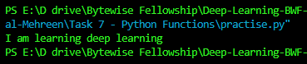

**Passing Arguments to Function**

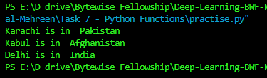

**Returning Values**

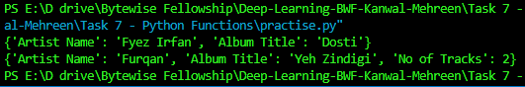

**Passing the Original List :**

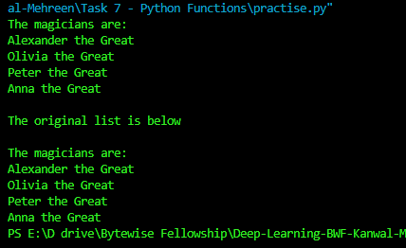

**Passing the Copy of the List**

**Using Arbitrary no of Arguments**

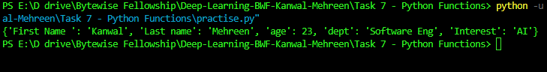

**DRY =** Dry stands for don’t repeat yourself and we basically aim to reduce the redundancies in our code. Functions are a great way to do so as we group the repetitive logic and just use the name of function to call it whenever required. It also provides a single place to make corrections in case of errors.